Q1.

The amplifier in the following figure consists of two identical common-emitter amplifiers connected in cascade. Observe that the input resistance of the second stage, $R_{in2}$, constitute the load resistance of the first stage.

1. For $V_{cc}=15V, R_{1}=100kΩ, R_{2}=47kΩ, R_{E}=3.9kΩ, R_{c}=6.8kΩ,$ and $β=100,$ determine the dc collector current and dc collector voltage of each transistor.
2. Draw the small-signal equivalent circuit of the entire amplifier and give the values of all its components.
3. Find $R_{in1}$ and $v_{b1}/v_{sig}$ for $R_{sig}=5kΩ$.
4. Find $R_{in2}$ and $v_{b2}/v_{b1}$.
5. For $R_{L}=2kΩ,$ find $v_{o}/v_{b2}$.
6. 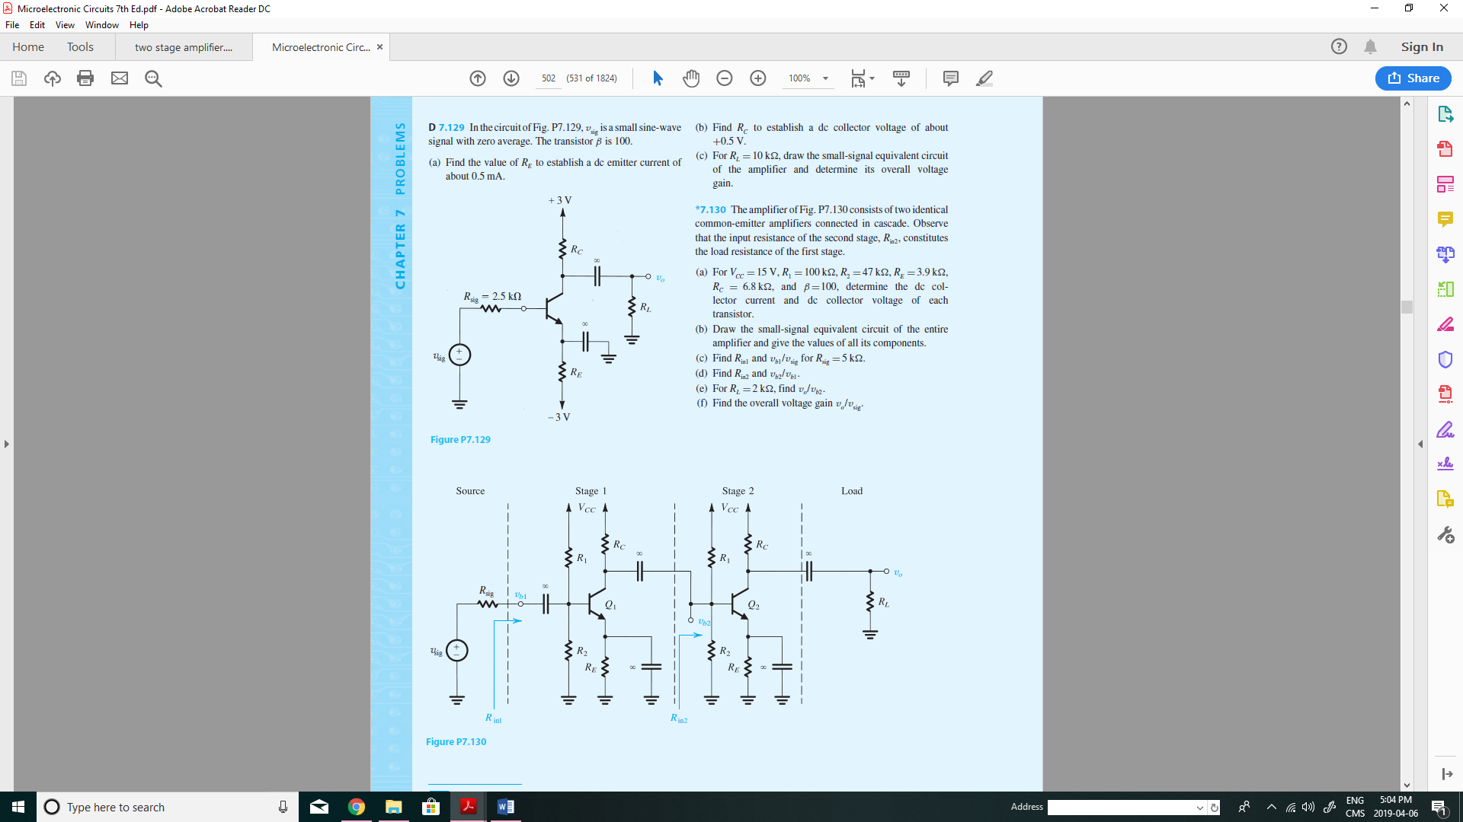Find the overall voltage gain $v_{o}/v_{sig}$.

Q2.

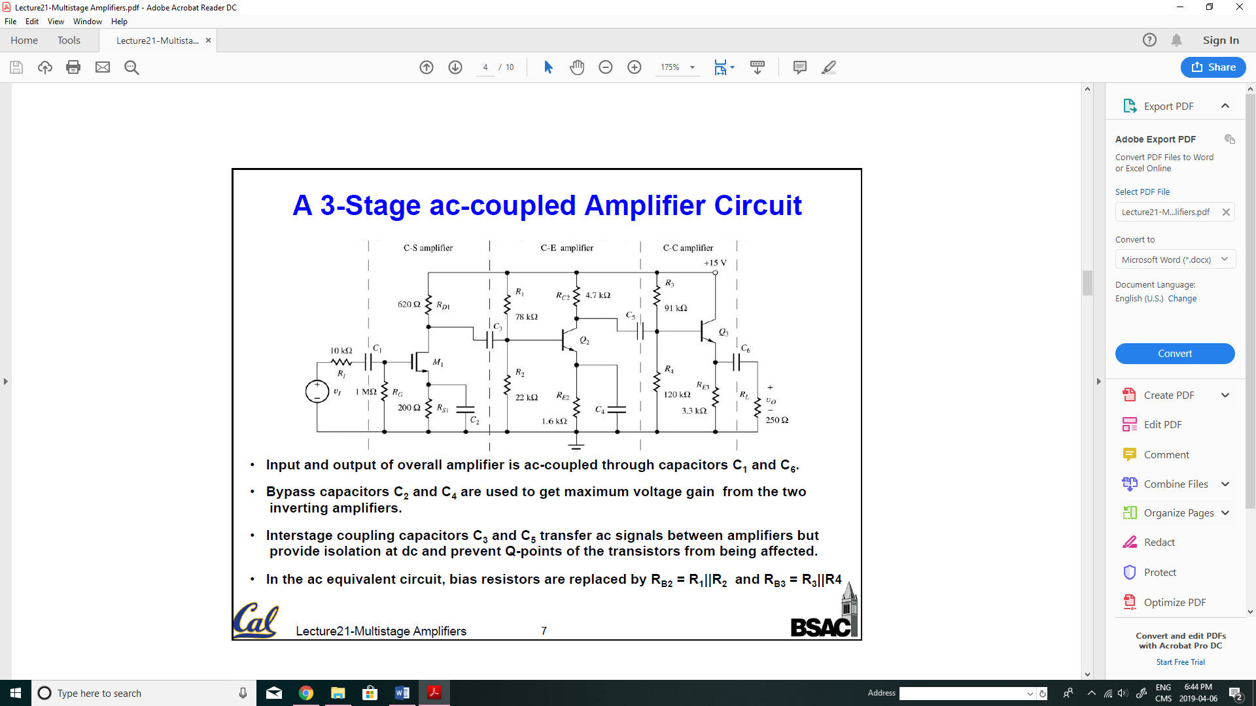In the following circuit, the MOSFET parameters are: $k_{n}=10\frac{mA}{V^{2}}, V_{t}=1 V, V_{A}=50 V,$ and the dc drain current $I_{D}=5 mA$, $V_{DS}=10V,$ the transistors $Q_{2}$ and $Q_{3}$ parameters are: $β=100, V_{A}=50 V$ and $V_{BE}=0.7V$. Find the input resistance, output resistance and the overall voltage gain.

Q3.

